#### Name Date

###### The effectiveness of the *Mind-Full* neurofeedback system for cueing sustained attention

# Abstract

Attentional issues are among the leading mental health challenges in North America today. Options to improve attentional abilities include pharmacological remedies as well as self-regulation (e.g. mediation, inward focus). However, the acquisition of self-regulation skills is not always easy. Neurofeedback-based systems have been shown to facilitate the learning of such techniques among children and adults, and technological advances like personal electroencephalogram (EEG) devices are making this type of treatment an increasingly affordable and viable option. Current research has focused on the benefits of using neurofeedback-based systems over an extended period of time. However, there remain at least two gaps in the literature. First, it is unclear whether neurofeedback-based training also has an *immediate* effect on attention. Second, researchers are unsure how many sessions are necessary for learning to take place. In this experiment, I help fill these gaps by exploring the short-term impact of a single neurofeedback-based session on sustained attention using a between-subjects experiment with 22 adults. Participants were3 exposed either to a functional neurofeedback-based game (“*Mind-Full*”) or shown a sham treatment of a prerecorded video of the game. I hypothesized that participants using the functioning neurofeedback-based system would perform better on a test of sustained attention (“SART”) than those who simply watched the video. Further, I anticipated that those using the game would have higher EEG attention levels as measured by the headset and would self-report higher attention levels. Results indicate …

**Keywords:** *neurofeedback, attention, self-regulation, mindful, sustained attention*

# Introduction

Attentional issues are among the leading mental health challenges in North America today (Kooij, 2013). These difficulties are closely associated with stress and often have negative impacts on self-esteem, productivity, and well-being (Barkley & Fischer, 2011; Prevatt, Dehili, Taylor, & Marshall, 2015). Although pharmacological remedies can be effective (Kooij, 2013), a less invasive strategy is the use of self-regulating techniques (Tang et al., 2007). These include deep breathing, inward focus, and meditation. However, the acquisition of self-regulation skills is not always easy. There are many approaches to facilitate learning self-regulation; and research has shown neurofeedback-based systems to be particularly useful in the acquisition of these skills (Budzynski, 2009).

Interventions involving electroencephalogram (EEG) neurofeedback technology have been in practice for several decades (Lubar, 1991). Through the observation of real-time brain activity, children and adults can better understand their mental state and learn to adjust it (Gruzelier, 2014). Studies have demonstrated that neurofeedback-based training can be especially effective in developing individuals’ sustained attention (T. Egner & Gruzelier, 2004; Tobias Egner & Gruzelier, 2001) which Manly et al. (Manly et al., 2001, p. 1066) define as the “capacity to maintain a particular processing set over time.” Until recently, much of this research was confined to laboratory settings due to the costly and sensitive nature of the equipment. However, with the advent of commercially available personal EEG devices, brain activity can now be monitored using a relatively inexpensive headset and mobile device (Rogers, Johnstone, Aminov, Donnelly, & Wilson, 2016). Studies using this new technology have shown to be effective in helping individuals learn to self-regulate (Antle, Chesick, Levisohn, Sridharan, & Tan, 2015; Chen & Huang, 2014).

Self-regulation skills improve with practice. Accordingly, much of the existing research reveals the positive effects of neurofeedback-based systems on individuals’ attentional abilities over extended periods of time (i.e. multiple sessions, spanning several weeks) (Tobias Egner & Gruzelier, 2001; Fuchs, Birbaumer, Lutzenberger, Gruzelier, & Kaiser, 2003). This long-term focus contributes to two gaps in the literature and in our applied knowledge. First, as Gruzelier (Gruzelier, 2014) notes, we do not know how many sessions are required for neurofeedback-based learning effects to take place. For example, Egner and Gruzelier (T. Egner & Gruzelier, 2004) describe a 10-session regimen to test improved attentional abilities, whereas Vernon et al. (Vernon et al., 2003) use an 8-session design. Repeated exposures may be sufficient for treatment effects, but there is no evidence to suggest they are necessarily more efficacious than a single exposure. In this study, I am interested in better understanding whether treatment effects are apparent after just one treatment session (without subsequent sessions). Second, it is unclear whether neurofeedback-based systems can have an *immediate* effect on sustained attention. For example, Vernon et al. (Vernon et al., 2003) studies treatment effects 4 weeks after initial exposure. Training with a neurofeedback-based system for several weeks may improve attentional abilities, but such a research design is time consuming and may be impractical in some real-world settings. In this study, I measure the outcome variable immediately following treatment, as opposed to days or weeks afterward. In this way, I aim to improve our knowledge of whether treatment effects are apparent in the short term. On a theoretical level, this study hopes to improve our understanding of the relationship between neurofeedback systems and attention – specifically, the conditioning effect of treatment frequency and duration.

This research builds on previous work using the neurofeedback-based game *Mind-Full*. *Mind-Full* is a mobile application that was developed for use with children who have experienced trauma or have attentional issues. Using commercially available EEG headset technology, *Mind-Full* provides real-time feedback on user’s stress and attention levels and rewards them for achieving customizable thresholds (Antle et al., 2015). It consists of three unique games (further discussed in section 2.2). By practicing these *Mind-Full* games in a controlled environment, users have been shown to improve their self-regulation over time (Antle et al., 2015). To investigate the immediate effectiveness of *Mind-Full* in the short term, I compare two groups: one that used the real game, and one that received a sham treatment. I hypothesize the following results:

***H1:*** *Participants using the Mind-Full neurofeedback-based game for a period of 10 minutes will make fewer errors of omission in a test of sustained attention (SART) than participants who observe the game without functioning neuro-feedback.*

***H2:*** *Participants who use the Mind-Full neurofeedback-based game will make fewer errors of commission in a test of sustained attention (SART) than those who view it without functioning neurofeedback.*

***H3:*** *Participants who use the Mind-Full neurofeedback-based game will have higher average attention brainwave scores during the intervention than participants who view it without functioning neurofeedback.*

***H4.*** *Participants who use the Mind-Full neurofeedback-based game will self-report higher attention levels than participants who view it without functioning neurofeedback.*

# Methods

**2.1 Participants**

A total of twenty-three students from Simon Fraser University’s undergraduate and graduate population voluntarily participated in this study (9 male). Participants received compensation either in the form of course credit or a $15 gift card. Ages of participants ranged from 18 to 25 (*M=*21.7). 3 participants reported having been previously diagnosed with an attentional disorder (ADHD/ADD). One individual described their symptoms as severe, and also scored highly on a pre-treatment Attention-Related Cognitive Errors Scale (ARCES) (Cheyne, Carriere, & Smilek, 2006). This participant’s data was removed from the analysis, bringing the final sample size to 22. This study was approved under the course ethics for IAT 802. All participants completed an informed consent form prior to taking part in the experiment.

###### 2.2 Stimuli and Apparatus

The *Mind-Full* game system consists of a NeuroSky Mindwave Mobile headset (figure 1), connected wirelessly to a 10” Samsung (Android) tablet. The headset has a single sensor that rests on a user’s forehead above their left eyebrow, and an ear clip which acts as a reference point to help reduce environmental noise (“NeuroSky,” n.d.). Information relating to electrical impulses in the user’s brain are transmitted in real-time via Bluetooth to the tablet. The incoming data consists of raw Alpha, Beta, Gamma, Delta, and Theta brainwave measurements, as well as algorithmically generated attention and meditation scores. Depending on which game the user is playing, an animation is triggered when the attention or meditation score is greater than a predefined threshold (figure 2). This feedback allows users to visually recognize when their brain activity changes, and rewards them with game tokens when this mental state is maintained. The game allows users to customize the threshold level, increasing the difficulty as they become more adept at controlling it over time. For the purposes of this experiment all thresholds were left at their default setting.

Participants were seated at a table for the duration of the session. An easel was placed on the table approximately 72cm from the participant. During the calibration and treatment stages of the experiment, a tablet was placed on the easel for the participant to view. For the calibration activity, the treatment group’s tablet contained the *Mind-Full* application “Pinwheel game”. During treatment, the tablet contained the *Mind-Full* application“Stone Game”. The control group were shown pre-recorded videos of another person’s game play of both games. They had no control over the animation.

Two measures of attention were used in this study. The Sustained Attention to Response Task (SART), as well as a survey based off of Millisecond’s Mind Wandering Probe (“Sustained Attention to Response Task (SART),” n.d.). The SART is an updated version of Strub and Black’s “A” Random Letter Test (Lezak, 2004). Participants sit at a computer while random numbers between 0-9 flash on the screen at a rate of 1 per second. Users are asked to press the spacebar every time a number that is not their target number appears. This test allows the observation of both errors of omission (i.e. not pressing the spacebar when a non-target number appears) as well as errors of commission (i.e. pressing the spacebar when the target appears). Minimizing errors, therefore, requires participants to remain focused for the duration the task. The code for this measure was obtained from Millisecond (“Sustained Attention to Response Task (SART),” n.d.) and was run locally on a MacBook Pro using Inquisit software.

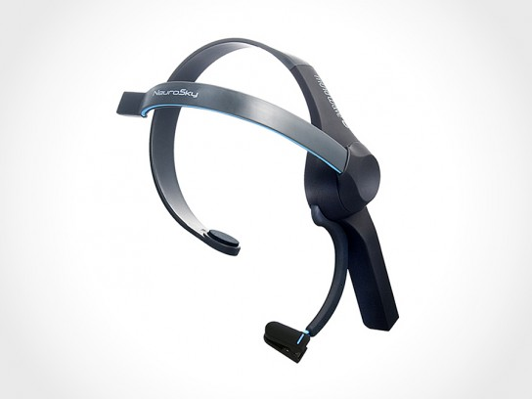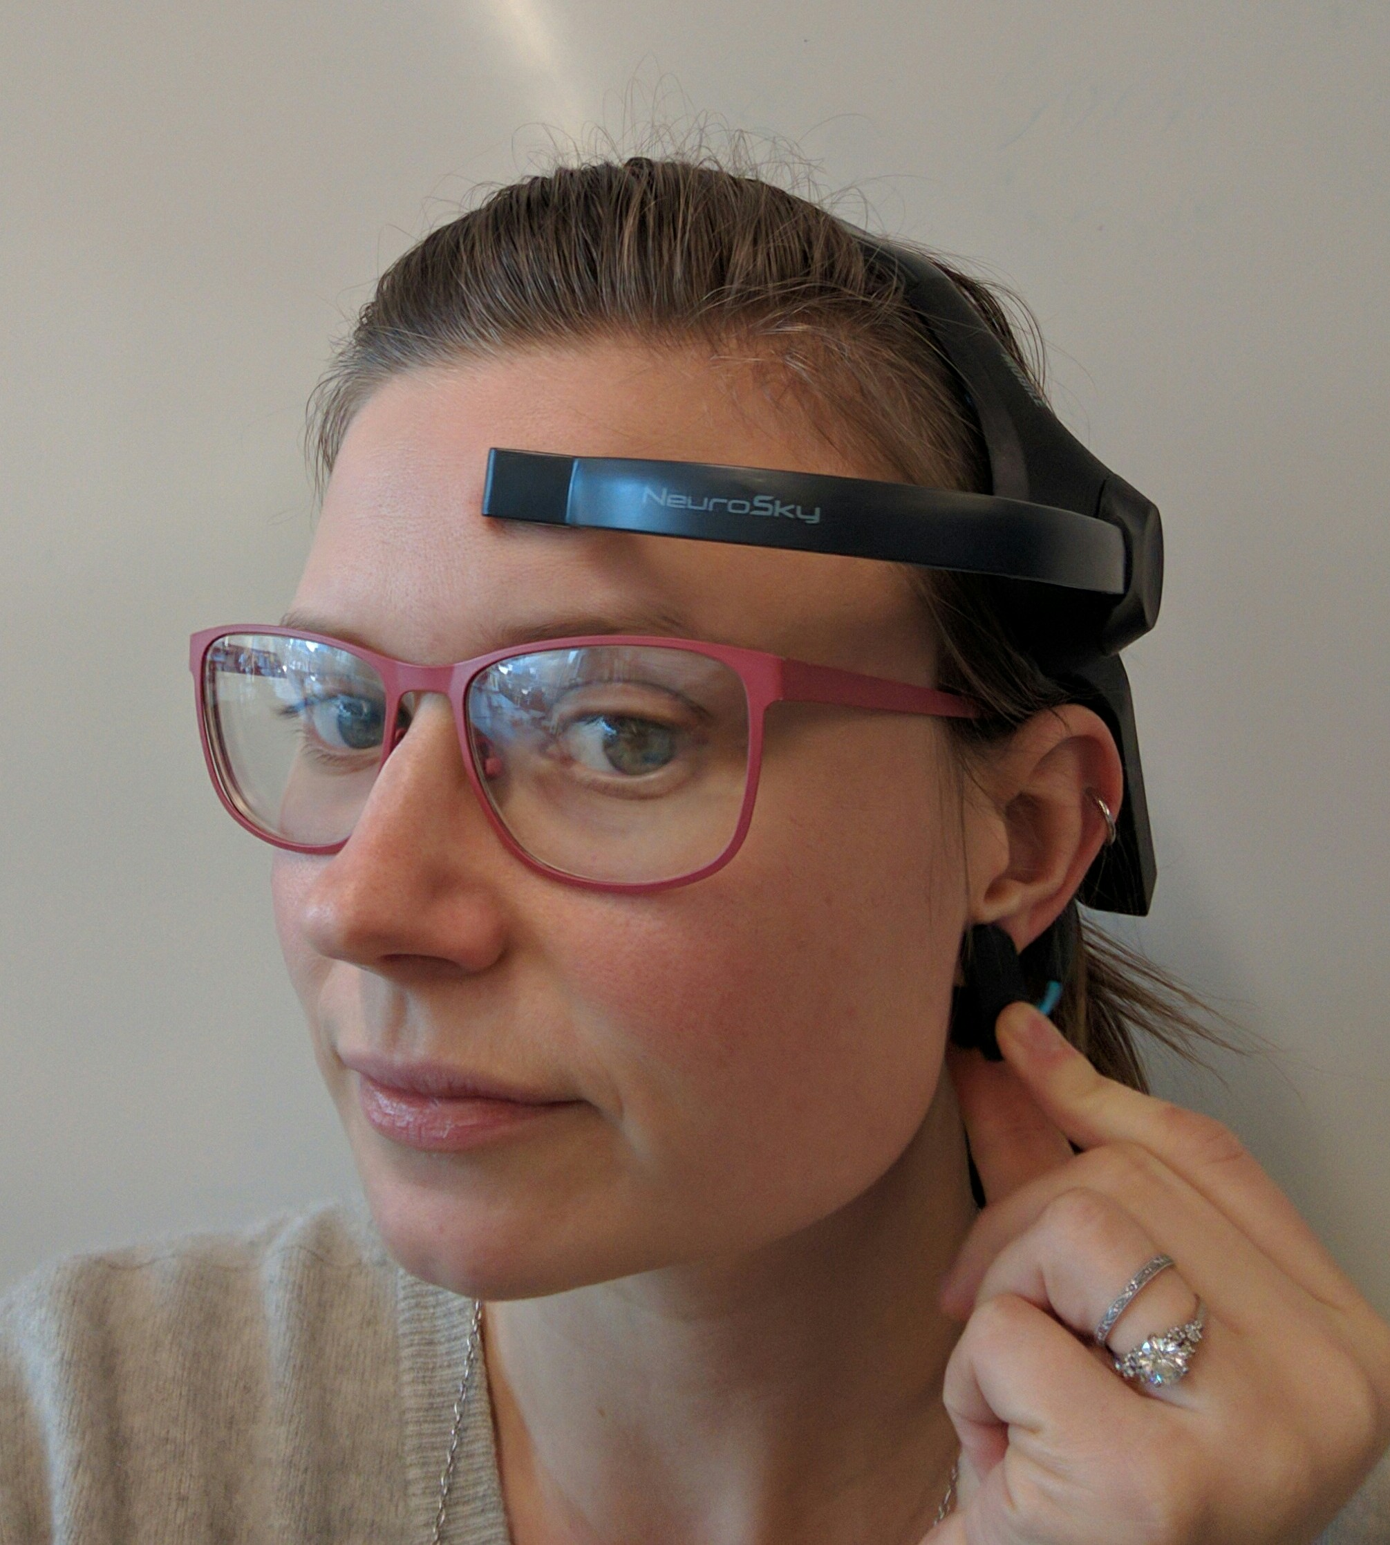

**Figure 1.** NeuroSky Mindwave Mobile headset promotional photo,   
and demonstration of correct sensor placement.

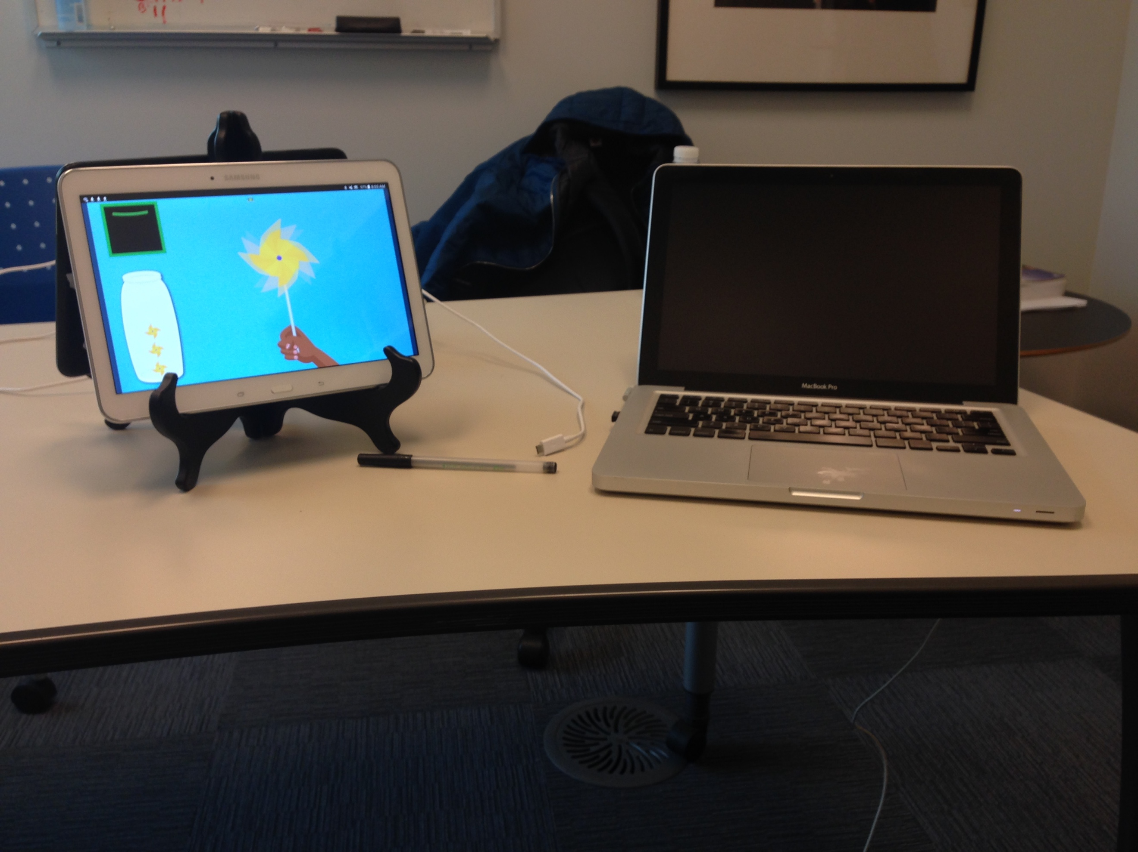

**Figure 2.** Participant's Workstation.

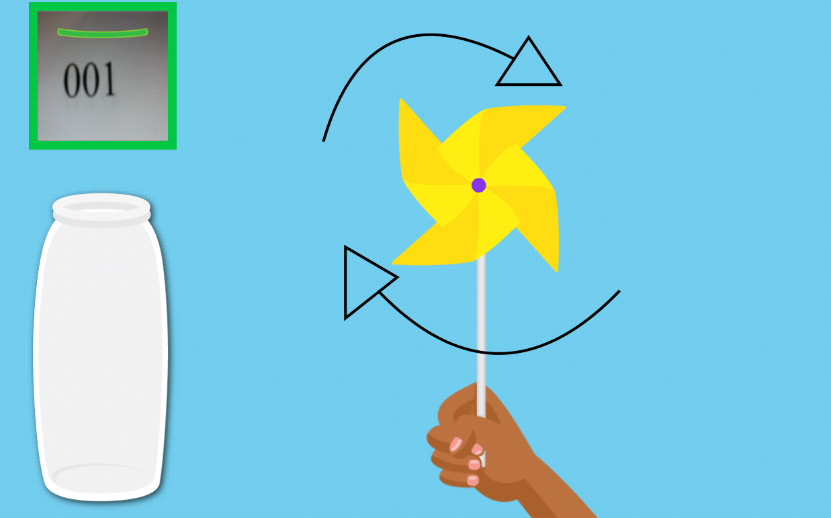

**Figure 3** Screenshots of the *Mind-Full* Pinwheel and Stone Games. Arrows indicate the direction of the animation triggered when the thresholds are crossed. Video of the Stone Game can be found at the following URL: https://vault.sfu.ca/index.php/s/dAupz3oy6zR4Fcb

**2.3 Procedure**

Participants were randomly allocated into one of two conditions, treatment (*n* = 12) or control (*n* = 10). Neither group was told explicitly that they could control the game with their brain activity, rather they were asked to focus and to “see if you can control it.” Both groups followed a similar procedure. First, the participants entered the lab, and were asked to sit at a table. Depending on scheduling, participants would either do the experiment alone, or with one other participant in the room (whose progress was blocked from view). Next, participants would complete the informed consent form and a demographics questionnaire. To ensure consistent instructions across sessions, a video was pre-recorded and played on a laptop.

Participants were then fitted with the NeuroSky headset, and used the *Mind-Full* Pinwheel relaxation game for two minutes to ensure a good connection; this process took longer when the headset required additional adjustment. To get a sense of whether participants experience significant attentional issues they were asked to complete an ARCES assessment. Next, participants completed a SART, looking for the target number 3, followed by a brief survey to assess their self-reported focus in the moment. Next they used the *Mind-Full* stone game for 10 minutes, followed by a second identical survey. Finally, they repeated the SART, this time looking instead for the target number 5; and completed a third, identical survey. At the end of the study, participants completed a questionnaire asking them about the experience, and if they have faced any anxiety or attentional issues in the past. A debrief was then held with each participant.

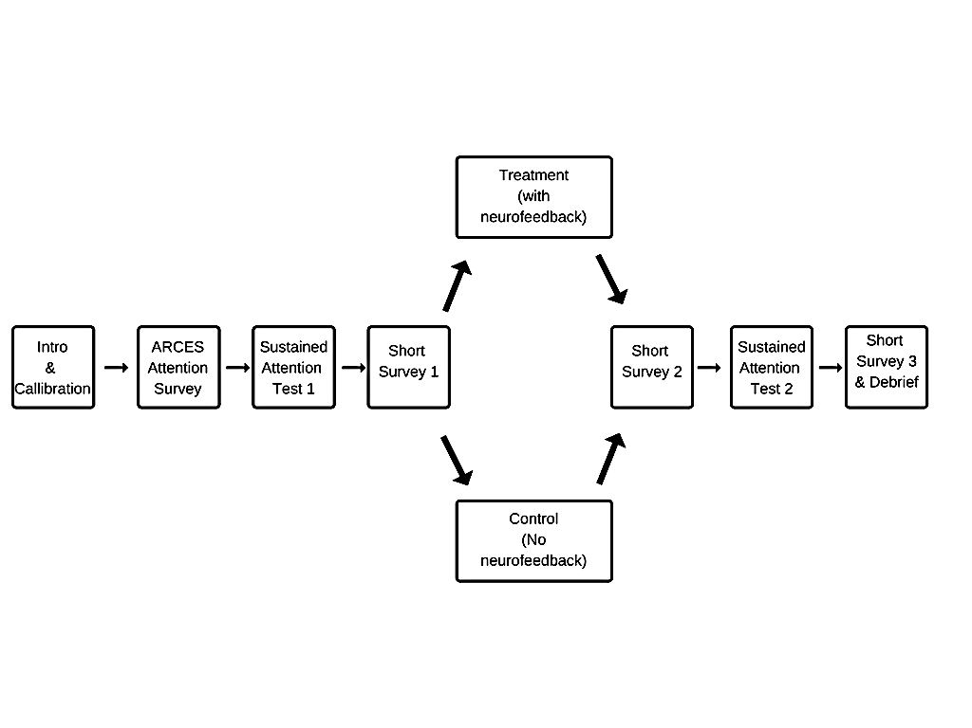 **Figure 4.** Experiment study design and measurement administration time points.

**2.4 Experimental Design**

This study had a 2 condition (neurofeedback condition: on, off) between-subjects design. Participants were randomly assigned to one of the two conditions. The experiment was a single session long and took approximately 40 minutes to complete. There were four dependent variables: SART errors of omission; SART errors of commission; average brainwave attention scores during the intervention; and responses to self-report surveys. Data for the SART and self-report attention survey were collected before and after the Mind-Full intervention (pre and post test points) and the self-report attention survey was also collected after final SART (post-SART test point) (as shown in Figure 4). The brainwave data was collected during the Mind-Full intervention.

**2.5 Data Analysis**

# Results

# Discussion

# Conclusion

# Acknowledgments

I would like to thank …

# References

Antle, A. N., Chesick, L., Levisohn, A., Sridharan, S. K., & Tan, P. (2015). Using Neurofeedback to Teach Self-regulation to Children Living in Poverty. In *Proceedings of the 14th International Conference on Interaction Design and Children* (pp. 119–128). New York, NY, USA: ACM. https://doi.org/10.1145/2771839.2771852

Barkley, R. A., & Fischer, M. (2011). Predicting Impairment in Major Life Activities and Occupational Functioning in Hyperactive Children as Adults: Self-Reported Executive Function (EF) Deficits Versus EF Tests. *Developmental Neuropsychology*, *36*(2), 137–161. https://doi.org/10.1080/87565641.2010.549877

Budzynski, T. (2009). *Introduction to quantitative EEG and neurofeedback: advanced theory and applications* (2nd ed.). London: Academic.

Chen, C.-M., & Huang, S.-H. (2014). Web-based reading annotation system with an attention-based self-regulated learning mechanism for promoting reading performance. *British Journal of Educational Technology*, *45*(5), 959–980. https://doi.org/10.1111/bjet.12119

Cheyne, J. A., Carriere, J. S. A., & Smilek, D. (2006). Attention-Related Cognitive Errors Scale. *PsycTESTS*. https://doi.org/10.1037/t23184-000

Egner, T., & Gruzelier, J. H. (2001). Learned self-regulation of EEG frequency components affects attention and event-related brain potentials in humans. *Neuroreport*, *12*(18), 4155–4159.

Egner, T., & Gruzelier, J. H. (2004). EEG Biofeedback of low beta band components: frequency-specific effects on variables of attention and event-related brain potentials. *Clinical Neurophysiology*, *115*(1), 131–139. https://doi.org/10.1016/S1388-2457(03)00353-5

Fuchs, T., Birbaumer, N., Lutzenberger, W., Gruzelier, J. H., & Kaiser, J. (2003). Neurofeedback Treatment for Attention-Deficit/Hyperactivity Disorder in Children: A Comparison with Methylphenidate. *Applied Psychophysiology and Biofeedback*, *28*(1), 1–12. https://doi.org/10.1023/A:1022353731579

Gruzelier, J. H. (2014). EEG-neurofeedback for optimising performance. I: A review of cognitive and affective outcome in healthy participants. *Neuroscience & Biobehavioral Reviews*, *44*, 124–141. https://doi.org/10.1016/j.neubiorev.2013.09.015

Kooij, J. S. (2013). *Adult ADHD: diagnostic assessment and treatment* (3rd ed). London ; New York: Springer.

Lezak, M. D. (2004). *Neuropsychological Assessment*. Oxford University Press.

Lubar, J. F. (1991). Discourse on the development of EEG diagnostics and biofeedback for attention-deficit/hyperactivity disorders. *Biofeedback and Self-Regulation*, *16*(3), 201–225. https://doi.org/10.1007/BF01000016

Manly, T., Anderson, V., Nimmo-Smith, I., Turner, A., Watson, P., & Robertson, I. H. (2001). The Differential Assessment of Children’s Attention: The Test of Everyday Attention for Children (TEA-Ch), Normative Sample and ADHD Performance. *Journal of Child Psychology and Psychiatry*, *42*(8), 1065–1081. https://doi.org/10.1111/1469-7610.00806

Prevatt, F., Dehili, V., Taylor, N., & Marshall, D. (2015). Anxiety in College Students With ADHD Relationship to Cognitive Functioning. *Journal of Attention Disorders*, *19*(3), 222–230. https://doi.org/10.1177/1087054712457037

Rogers, J. M., Johnstone, S. J., Aminov, A., Donnelly, J., & Wilson, P. H. (2016). Test-retest reliability of a single-channel, wireless EEG system. *International Journal of Psychophysiology*, *106*, 87–96. https://doi.org/10.1016/j.ijpsycho.2016.06.006

Sustained Attention to Response Task (SART). (n.d.). Retrieved December 9, 2016, from http://www.millisecond.com/download/library/SART/

Tang, Y.-Y., Ma, Y., Wang, J., Fan, Y., Feng, S., Lu, Q., … Posner, M. I. (2007). Short-term meditation training improves attention and self-regulation. *Proceedings of the National Academy of Sciences of the United States of America*, *104*(43), 17152–17156. https://doi.org/10.1073/pnas.0707678104

Vernon, D., Egner, T., Cooper, N., Compton, T., Neilands, C., Sheri, A., & Gruzelier, J. (2003). The effect of training distinct neurofeedback protocols on aspects of cognitive performance. *International Journal of Psychophysiology*, *47*(1), 75–85. https://doi.org/10.1016/S0167-8760(02)00091-0

**Appendix**



Appendix 1. Raw data plot for errors of omission pre/post treatment



Appendix 2. Raw data plot for errors of commission pre/post treatment



Appendix 3. Raw data plot for participants’ average brainwave attention score during treatment



Appendix 4. Raw data plot of participants’ self-report attention score